Analytical Decision Modeling I

|  |  |
| --- | --- |
| Project report  Project Sponsor: Trueno Electric Vehicles | **Team: 22292**   1. **Chetas Anand** 2. **Gaurav Jethe** 3. **Namaskrutha Reddy Ghanta** 4. **Rushabh Shah** 5. **Tian Xia** |

https://www.gotrueno.com/

**Agenda:**

Executive Summary……………………………………………………………………………………….…….3

Company Information…………………………………………………………………………………….……4

Objective……………………………………………………………………………………………………….…….5

Methodology…………………………………………………………………………………………………….…5

Background…………………………………………………………..……………………………………………..3

Model Setup………………………………………………………………………………………………………...8

Excel model………………………………………………………………………………………..…..……………8

Solution………………………………………………………………………………………………………………..9

Conclusion……………..…………………………………………………………………………..………………..9

Recommendation…..……………………………………………………………..……………………………..9

**Executive Summary:**

The Indian automotive market is stated to be the third largest by 2030 in terms of volume. Catering to a vast domestic market, reliance on the conventional modes of fuel-intensive mobility will not be sustainable. In an effort to address this, federal policymakers are developing an Electric mobility option.

Trueno, a One Stop Electric Two-Wheeler Rental Platform for Last Mile Delivery Businesses based out of Mumbai thrives to replace the fuel vehicle fleet to electric. It serves businesses that are into hyper-local and first/last mile deliveries like logistics and e-commerce businesses, etc. They have currently grown to a fleet of 200 vehicles in Mumbai.

In this project, we have helped Trueno identify the number of batteries swapping points and its location in Mumbai considering all their client locations. We analyzed the IoT data from all the vehicles to obtain vehicle coordinates to determine the best locations of these battery swapping stations.

Company Information:

India’s electric vehicle market size was valued at USD 1.45 billion in 2021.

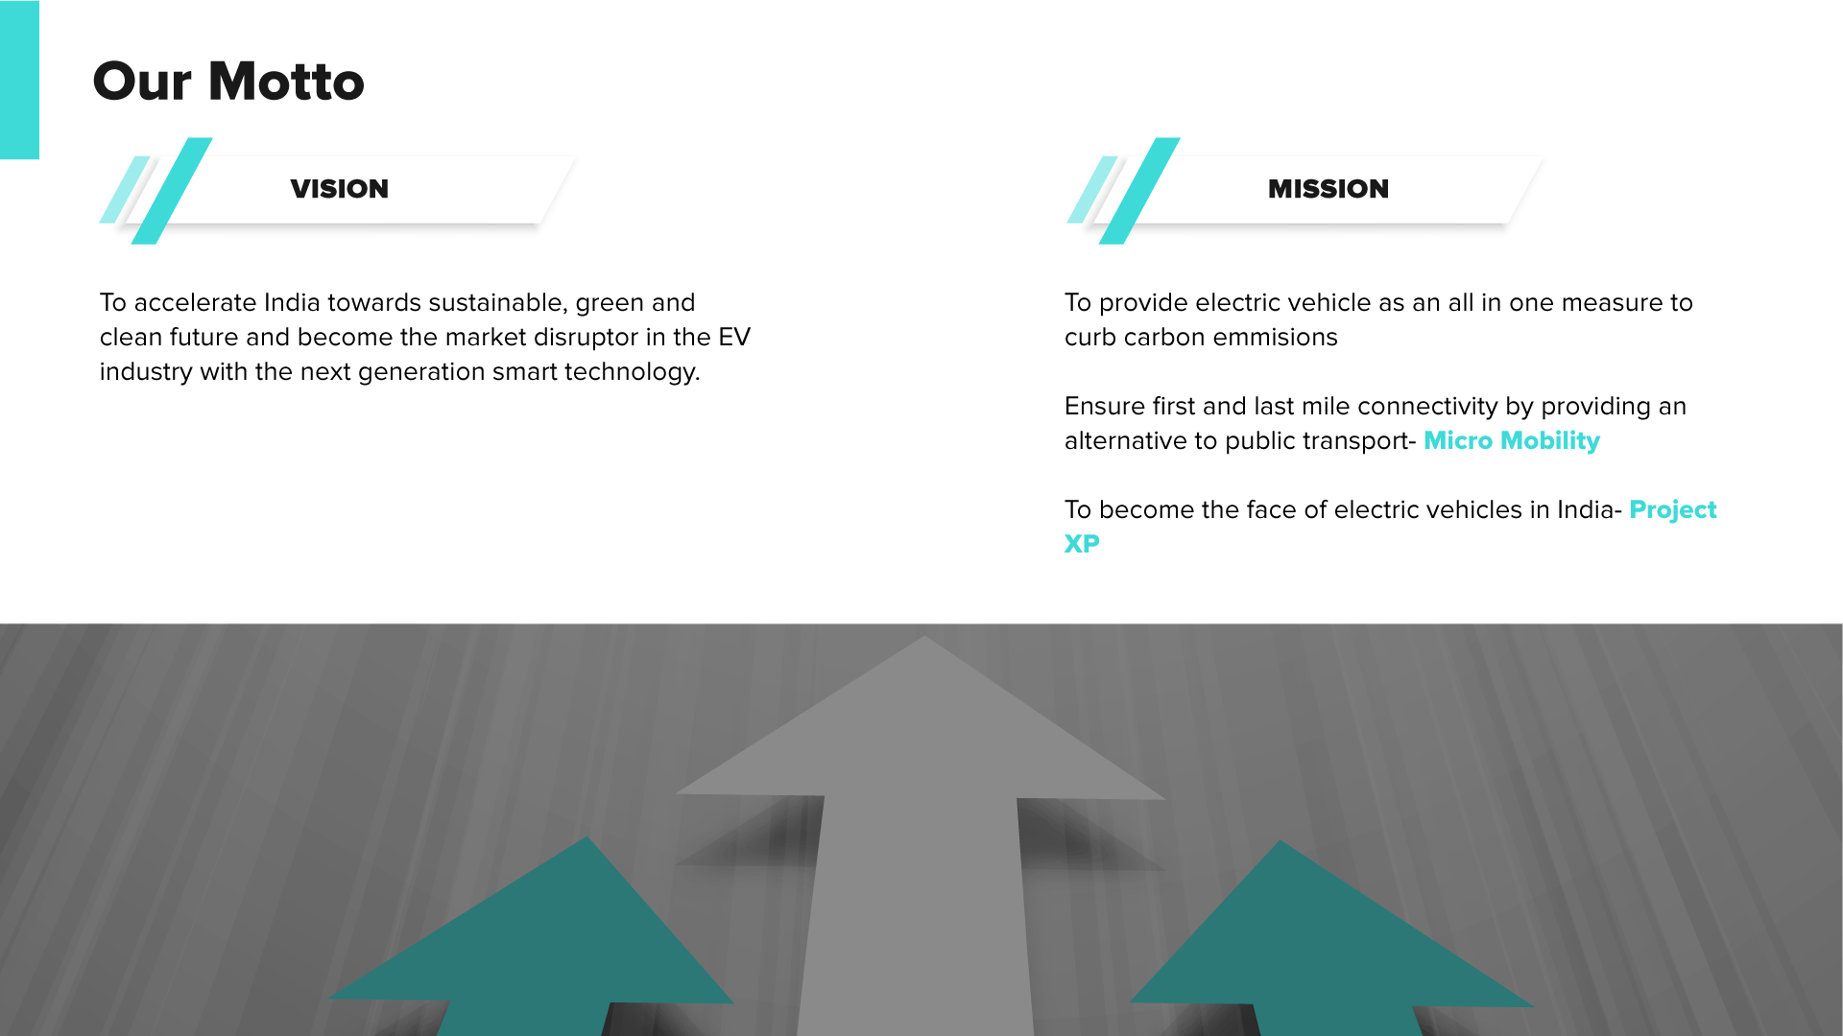

**https://www.gotrueno.com/**

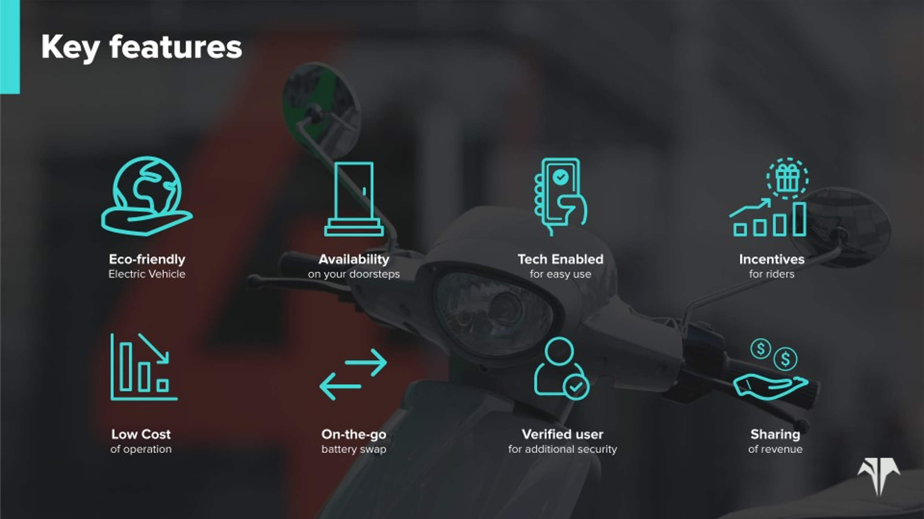

**Offerings:**

·       IoT fitted portable battery Electric two-wheelers

·       AI/ML-enabled connected electric mobility central intelligence Ecosystem

·       Network of Local mechanics for quick and efficient servicing

**What we do:**

Trueno provides the best-fit Electric two-wheeler in the market on a rental basis to businesses. The company digitalizes customer operations by collaboratively enhancing customers’ operations using house Analytical and platform capabilities. It caters to all the Electric two-wheeler servicing through our Local Mechanic aggregator platform

Objective:

This project explores the possibilities of using Optimization to determine the total number of batteries swapping stations, its location and provide the optimized locations of battery swapping stations

Business Problem:

In this project, we are trying to solve two business problems using Optimization,

1. To determine the total number of battery-swapping stations

We can see that the clients waste a lot of time in charging their vehicles in the middle of the day. They need battery swapping points in their locations so that they do not need to return to the hub and charge the vehicle, they can swap the battery in the vehicle at minimal cost and continue their deliveries to customers

1. To determine the battery swapping Location

Battery swapping stations can be established in the existing client locations. Considering, minimum stations are established at these client locations that it can suffice the demand for all the clients in Mumbai. There is basically a need to select the strategic locations of these battery swapping points as adding these stations at every client location can be expensive.

Methodology:

## Overview:

Here, we used Integer programming model to find minimum number and respective locations of batteries swapping locations in Mumbai.

## Data collection:

We collected data of client operating location and distance to each location from Trueno CRM portal. From this data, we constructed an excel model. Additional data was obtained by interviewing the founder of the company.

## Method:

We used an Integer index for each client location, i.e. i, j. Then we made Ai,j matrix where the distance between locations is less than 7 kms. The average travel distance of an electric bike on a trip is approximately 7 kms. Hence, we took 7 kms as a cutoff so that they can reach the battery swapping station when required without any hassle. We took xj as a decision variable and minimized sum of xj. We added a constraint to ensure that all client locations must be close to battery swap stations. Since this is an Integer Programming model, we have xj as binary.

Based on this model, we got the optimal number and location of charging stations.

## Background:

Trueno has 11 clients in Mumbai. There are various numbers of vehicles that these clients use for their delivery purposes. Vehicles of Trueno are parked at client’s locations and Trueno realizes revenue using a subscription model from these clients.

Each two-wheeler travels 60km on a complete charge. But as the requirement of client of per day is more than 60km, the electric vehicle needs to be charged couple of times in a day. It becomes a challenge for the client to get back the vehicles at the hub each time to charge the vehicle 2-3 times.

Trueno wants to create battery swapping points in various client locations so that every time the vehicle gets discharged in between it can go to the nearest other client location and swap the battery with new charged battery.

Every client has a different number of vehicles and number of orders it delivers in a day. The total trips covered by each client are a product of the number of vehicles per client and the number of orders. The cost of each battery swapping is Rs.15.

Every vehicle is IoT-fitted. Hence there is real-time data is captured of the two-wheeler.

Model Setup:

## Input:

i, j {1,2,3,4,5,6,7,8,9,10,11}: index of client location

di,j : Distance from location i to j.

Ai,j : set of valid tuples where distance between i and j is less than 7 km

## Decision Variable:

xj: whether to place a battery swapping station at location j

## Objective:

## Constraints:

1. where i{1….,11} [All client locations must be close to a battery swap station]

(2) xj {0,1} [Binary constraint]

Excel Model:



**Ai, j:** Tuple



Solution:



Conclusion:

As per the data, 4 battery swapping stations are optimal number of stations which needs to be set up. These 4 stations should be located at Saki Naka, International Airport, Kandivli E and Malad client locations

Recommendation:

To make this model more accurate to battery swapping demand, data of demand at each location needs to be collected which will help us to make better decision of accurately placing the battery swapping stations.